**Липецкий государственный технический университет**

Факультет автоматизации и информатики

Кафедра автоматизированных систем управления

ЛАБОРАТОРНАЯ РАБОТА №3

по дисциплине «Базы данных»

Разработка физической модели данных и создание БД

Студент Станиславчук С.М.

Группа АС-21-1

Руководитель Алексеев В.А.

Липецк 2023 г.

Цель работы

Изучить задачи физического проектирования базы данных. Освоить на практике разработку физической модели данных в среде Sybase PowerDesigner и модификацию схемы данных с использованием SQL-запросов.

Задание кафедры

Сформировать в среде PowerDesigner физическую модель данных на основе логической модели, разработанной в лабораторной работе №2. Создать базу данных средствами выбранной СУБД и отработать сценарий модификации схемы данных.

Ход работы

На рисунке 1 представлена диаграмма физической модели.

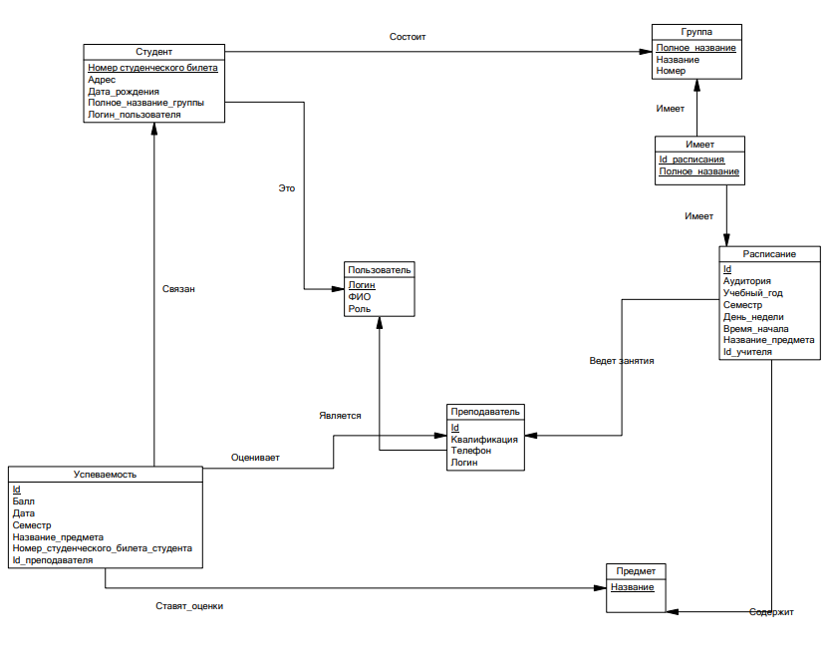

Рисунок 1 – Физическая модель

Спецификация таблиц

Спецификация таблиц физической модели составлена и заполнена в виде таблицы 1.

Таблица 1 – Спецификация сущностей физической модели

|  |  |  |  |  |  |  |  |
| --- | --- | --- | --- | --- | --- | --- | --- |
| **Имя сущности** | **Код сущности** | **Имя атрибута** | **Код атрибута** | **Обязательность** | **Первичный ключ** | **Внешний ключ** | **Домен** |
| Студент | Student | Номер студенческого билета | id_number_student | T | T | F | Number (10) |
| Дата рождения | birth_date_student | T | F | F | Date |
| Адрес | address_student | T | F | F | VARCHAR |
| **Полное_название_группы** | **full_name_group** | T | F | T | VARCHAR (256) |
| **Логин_пользователя** | **login_user** | T | F | T | VARCHAR (256) |
| Группа | Group | Полное название | full_name_group | T | T | F | VARCHAR |
| Название | name_group | T | F | F | VARCHAR (10) |
| Номер | number_group | T | F | F | Number |
| Преподаватель | Teacher | Id | Id_teacher | T | T | F | Serial |
| Квалификация | qualification_teacher | T | F | F | VARCHAR |
| Телефон | phone_number_teacher | F | F | F | NUMBER (11) |
| Логин | login_user | T | F | T | VARCHAR (256) |
| Пользователь | User | Логин | login_user | T | T | F | VARCHAR |
| ФИО | full_name_user | T | F | F | VARCHAR |
| Роль | role_user | T | F | F | VARCHAR |
| Расписание | Schedule | Id | id_schedule | T | T | F | Serial |
| Аудитория | class_schedule | T | F | F | VARCHAR |
| Учебный год | academic_year_schedule | T | F | F | Number (9) |
| Семестр | semetster_sche dule | T | F | F | Number (1) |
| День недели | weekday_schedule | T | F | F | VARCHAR |
| Время начала | start_time_schedule | T | F | F | Time |
| Название_предмета | name_subject | T | F | T | VARCHAR (256) |
| Id_учителя | Id_teacher | T | F | T | INT4 |
| Предмет | Subject | Название | name_subject | T | T | F | VARCHAR |
| Успеваемость | Perfomance | Id | Id_perfomance | T | T | F | Serial |
| Балл | mark_perfomance | T | F | F | Number (3) |
| Дата | date_perfomance | T | F | F | Date |
| Семестр | semester_perfo mance | T | F | F | VARCHAR (6) |
| Название_предмета | name_subject | T | F | T | VARCHAR(256) |
| Номер_студенческого_билета_студента | Id_number_student | T | F | T | NUMERIC |
| Id_преподавателя | Id_teacher | T | F | T | INT4 |
| Имеет | group_has_schedules | Id_расписания | Id_schedule | T | T | T | INT4 |
| Полное_название | full_name_group | T | T | T | VARCHAR(256) |

Создание базы данных

Сгенерированный SQL-скрипт:

/*==============================================================*/

/* DBMS name: PostgreSQL 8 */

/* Created on: 26.11.2023 20:41:34 */

/*==============================================================*/

drop index if exists Group_PK;

drop table if exists "Group";

drop index if exists teacher_perfomance_FK;

drop index if exists student_perfomance_FK;

drop index if exists subject_perfomance_FK;

drop index if exists Perfomance_PK;

drop table if exists Perfomance;

drop index if exists teacher_schedule_FK;

drop index if exists schedule_subject_FK;

drop index if exists Schedule_PK;

drop table if exists Schedule;

drop index if exists student_is_user_FK;

drop index if exists student_group_FK;

drop index if exists Student_PK;

drop table if exists Student;

drop index if exists Subject_PK;

drop table if exists Subject;

drop index if exists teacher_is_user_FK;

drop index if exists Teacher_PK;

drop table if exists Teacher;

drop index if exists User_PK;

drop table if exists "User";

drop index if exists schedule_has_group_FK;

drop index if exists group_has_schedules_FK;

drop index if exists group_has_schedules_PK;

drop table if exists group_has_schedules;

/*==============================================================*/

/* Table: "Group" */

/*==============================================================*/

create table "Group" (

full_name_group VARCHAR(256) not null,

name_group VARCHAR(10) not null,

number_group NUMERIC not null,

constraint PK_GROUP primary key (full_name_group)

);

/*==============================================================*/

/* Index: Group_PK */

/*==============================================================*/

create unique index Group_PK on "Group" (

full_name_group

);

/*==============================================================*/

/* Table: Perfomance */

/*==============================================================*/

create table Perfomance (

Id_perfomance SERIAL not null,

mark_perfomance NUMERIC(3) not null,

date_perfomance DATE not null,

semester_perfomance VARCHAR(6) not null,

name_subject VARCHAR(256) not null,

Id_number_student NUMERIC not null,

Id_teacher INT4 not null,

constraint PK_PERFOMANCE primary key (Id_perfomance)

);

/*==============================================================*/

/* Index: Perfomance_PK */

/*==============================================================*/

create unique index Perfomance_PK on Perfomance (

Id_perfomance

);

/*==============================================================*/

/* Index: subject_perfomance_FK */

/*==============================================================*/

create index subject_perfomance_FK on Perfomance (

name_subject

);

/*==============================================================*/

/* Index: student_perfomance_FK */

/*==============================================================*/

create index student_perfomance_FK on Perfomance (

Id_number_student

);

/*==============================================================*/

/* Index: teacher_perfomance_FK */

/*==============================================================*/

create index teacher_perfomance_FK on Perfomance (

Id_teacher

);

/*==============================================================*/

/* Table: Schedule */

/*==============================================================*/

create table Schedule (

Id_schedule SERIAL not null,

class_schedule VARCHAR(256) not null,

academic_year_schedule NUMERIC(9) not null,

semester_schedule NUMERIC(1) not null,

weekday_schedule VARCHAR(256) not null,

start_time_schedule TIME not null,

name_subject VARCHAR(256) not null,

Id_teacher INT4 null,

constraint PK_SCHEDULE primary key (Id_schedule)

);

/*==============================================================*/

/* Index: Schedule_PK */

/*==============================================================*/

create unique index Schedule_PK on Schedule (

Id_schedule

);

/*==============================================================*/

/* Index: schedule_subject_FK */

/*==============================================================*/

create index schedule_subject_FK on Schedule (

name_subject

);

/*==============================================================*/

/* Index: teacher_schedule_FK */

/*==============================================================*/

create index teacher_schedule_FK on Schedule (

Id_teacher

);

/*==============================================================*/

/* Table: Student */

/*==============================================================*/

create table Student (

id_number_student NUMERIC not null,

address_student VARCHAR(256) not null,

birth_date_student DATE not null,

full_name_group VARCHAR(256) not null,

login_user VARCHAR(256) not null,

constraint PK_STUDENT primary key (id_number_student)

);

/*==============================================================*/

/* Index: Student_PK */

/*==============================================================*/

create unique index Student_PK on Student (

id_number_student

);

/*==============================================================*/

/* Index: student_group_FK */

/*==============================================================*/

create index student_group_FK on Student (

full_name_group

);

/*==============================================================*/

/* Index: student_is_user_FK */

/*==============================================================*/

create index student_is_user_FK on Student (

login_user

);

/*==============================================================*/

/* Table: Subject */

/*==============================================================*/

create table Subject (

name_subject VARCHAR(256) not null,

constraint PK_SUBJECT primary key (name_subject)

);

/*==============================================================*/

/* Index: Subject_PK */

/*==============================================================*/

create unique index Subject_PK on Subject (

name_subject

);

/*==============================================================*/

/* Table: Teacher */

/*==============================================================*/

create table Teacher (

Id_teacher SERIAL not null,

qualification_teacher VARCHAR(256) not null,

phone_number_teacher NUMERIC(11) null,

login_user VARCHAR(256) not null,

constraint PK_TEACHER primary key (Id_teacher)

);

/*==============================================================*/

/* Index: Teacher_PK */

/*==============================================================*/

create unique index Teacher_PK on Teacher (

Id_teacher

);

/*==============================================================*/

/* Index: teacher_is_user_FK */

/*==============================================================*/

create index teacher_is_user_FK on Teacher (

login_user

);

/*==============================================================*/

/* Table: "User" */

/*==============================================================*/

create table "User" (

login_user VARCHAR(256) not null,

full_name_user VARCHAR(256) not null,

role_user VARCHAR(256) not null,

constraint PK_USER primary key (login_user)

);

/*==============================================================*/

/* Index: User_PK */

/*==============================================================*/

create unique index User_PK on "User" (

login_user

);

/*==============================================================*/

/* Table: group_has_schedules */

/*==============================================================*/

create table group_has_schedules (

Id_schedule INT4 not null,

full_name_group VARCHAR(256) not null,

constraint PK_GROUP_HAS_SCHEDULES primary key (Id_schedule, full_name_group)

);

/*==============================================================*/

/* Index: group_has_schedules_PK */

/*==============================================================*/

create unique index group_has_schedules_PK on group_has_schedules (

Id_schedule,

full_name_group

);

/*==============================================================*/

/* Index: group_has_schedules_FK */

/*==============================================================*/

create index group_has_schedules_FK on group_has_schedules (

full_name_group

);

/*==============================================================*/

/* Index: schedule_has_group_FK */

/*==============================================================*/

create index schedule_has_group_FK on group_has_schedules (

Id_schedule

);

alter table Perfomance

add constraint FK_PERFOMAN_STUDENT_P_STUDENT foreign key (Id_number_student)

references Student (id_number_student)

on delete cascade on update cascade;

alter table Perfomance

add constraint FK_PERFOMAN_SUBJECT_P_SUBJECT foreign key (name_subject)

references Subject (name_subject)

on delete cascade on update cascade;

alter table Perfomance

add constraint FK_PERFOMAN_TEACHER_P_TEACHER foreign key (Id_teacher)

references Teacher (Id_teacher)

on delete cascade on update cascade;

alter table Schedule

add constraint FK_SCHEDULE_SCHEDULE__SUBJECT foreign key (name_subject)

references Subject (name_subject)

on delete set null on update restrict;

alter table Schedule

add constraint FK_SCHEDULE_TEACHER_S_TEACHER foreign key (Id_teacher)

references Teacher (Id_teacher)

on delete set null on update restrict;

alter table Student

add constraint FK_STUDENT_STUDENT_G_GROUP foreign key (full_name_group)

references "Group" (full_name_group)

on delete restrict on update restrict;

alter table Student

add constraint FK_STUDENT_STUDENT_I_USER foreign key (login_user)

references "User" (login_user)

on delete restrict on update restrict;

alter table Teacher

add constraint FK_TEACHER_TEACHER_I_USER foreign key (login_user)

references "User" (login_user)

on delete restrict on update restrict;

alter table group_has_schedules

add constraint FK_GROUP_HA_GROUP_HAS_GROUP foreign key (full_name_group)

references "Group" (full_name_group)

on delete set null on update restrict;

alter table group_has_schedules

add constraint FK_GROUP_HA_SCHEDULE__SCHEDULE foreign key (Id_schedule)

references Schedule (Id_schedule)

on delete set null on update restrict;

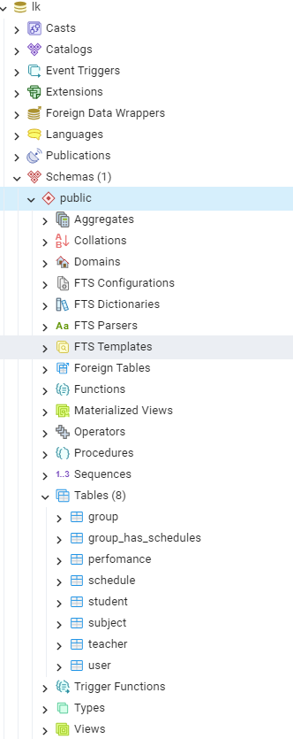

Рисунок 2 – Скриншот управления выбранной СУБД

Сценарий модификации БД

Описание сценария

Сценарий заключается в том, чтобы добавить новую таблицу с информацией о поставке книг и учебников в библиотеку ВУЗа. В ней будут атрибуты: «Название учебного материала», «Количество», «Дата доставки».

Код SQL-запросов модификации базы данных:

-- Создание таблицы

CREATE TABLE supply (

IdSupply SERIAL PRIMARY KEY,

materialName VARCHAR(100) NOT NULL,

quantity INT NOT NULL,

deliveryDate DATE NOT NULL

);

-- Добавление колонки «Название предмета» в таблицу

ALTER TABLE supply

ADD COLUMN subjectName VARCHAR (256) NOT NULL;

-- Создание ограничения внешнего ключа для связи новой таблицы с существующей (учебный материал связан с предметами)

ALTER TABLE supply

ADD CONSTRAINT subjectSupply

FOREIGN KEY (subjectName) REFERENCES subject(name_subject);

-- Модификация колонки в таблице

ALTER TABLE supply

ALTER COLUMN materialName type varchar (90);

-- Удаление колонки в таблице

ALTER TABLE supply

DROP COLUMN deliveryDate;

-- Удаление таблицы

DROP TABLE supply;

Вывод

По итогу выполнения данной лабораторной работы я изучил задачи физического проектирования базы данных. А также освоил на практике разработку физической модели данных в среде Sybase PowerDesigner и модификацию схемы данных с использованием SQL-запросов.